LIGBI NTƆRE, DYOGO

people name Dyogo, Ligbi (in Menji and Namasa), Ntɔrɛ (in Brohani, Buku, and Kwame Tenten) also, Wela, or Gyogoh; or Bamba, which refers to the crocodile, the Ligbi symbol or totem.
language Ligbi, Dyogoyagbra (Menji) Ntɔrɛ (Brohani)
home area Ligbi about 250 km
main towns Brohani (population 1970 1,815; 1984 2,575; 2000 4,361) Menji (population 1970 1,54;1 1984 1,640; 2000 2,311;
other local peoples Nafana, Kulango, Dyula
chiefs Brohani: in 2008 the skin was vacant [has any chief been enstooled yet?] Menji: (1980s to 2008) Alhaji Lamini (Nana Adesa III)
name of God [do Ligbi use any other name apart from Allah?]
principal local god Adingara? Sirigboe?
main occupation farming and blacksmithing [how many blacksmiths now in Brohani? in Menji?]
location Ligbi comprises 5 towns in Brong Ahafo,, some 20 km north-west of Wenchi, and just north of the site of ancient Begho.
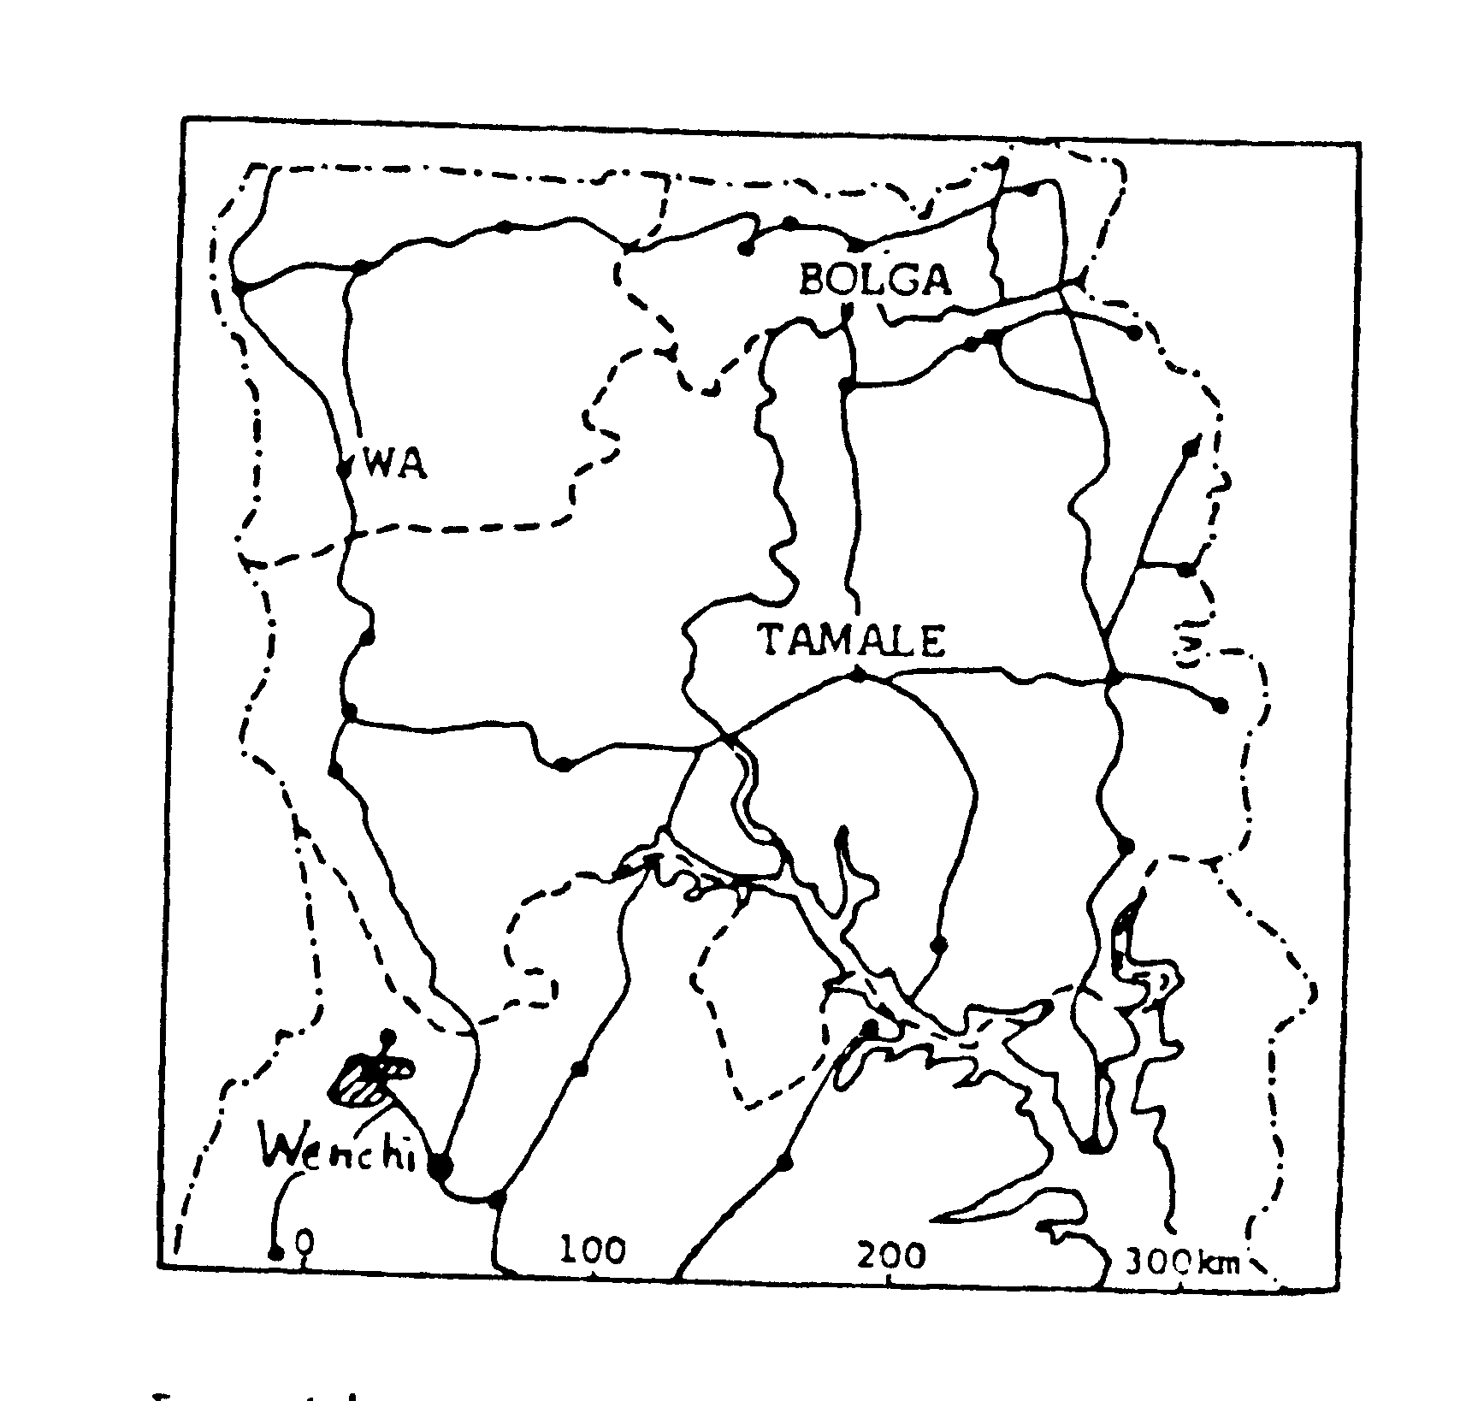

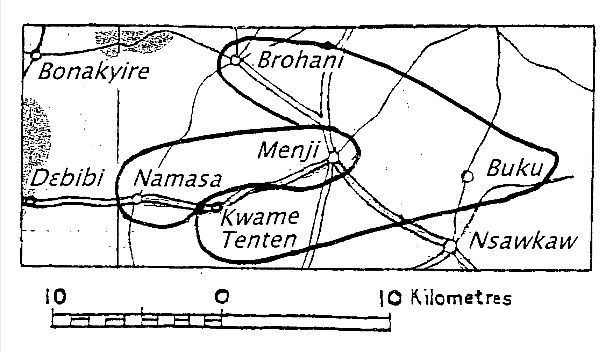

POPULAR INTRODUCTION (this may perhaps be written by Dauda Mohamed)
LIGBI POPULATION
Table 1 LIGBI – COMPARED BY YEAR
 | 1984 estimate | 1991 Ethnologue | 2000 Census | 2003 Ethnologue est | 2010 estimate
3 N Regions
Brong Ahafo | 6,300
All Other Regions | 200
GHANA Total | 6,500 |  | not listed | 15,000 | 15,000
CÔTE d’IVOIRE |  | 4,000
Table 2 LIGBI - COMPARED BY REGION
Northern regions
Upper East | Upper West | Northern | NORTH TOTAL
Southern regions
Western | Central | Greater Accra | Volta
Eastern | Ashanti | Brong Ahafo | SOUTH TOTAL
GHANA Total |  |  | 15,000
[please name any towns where you know of Ligbi communities]
MIGRATION
People migrate to earn money for basic necessities. Others leave home to get away from quarrels and family problems. Most migrants stay in Muslim zongos and stick to their Muslim faith. Berekum, Wenchi, Kumasi, and the Côte d’Ivoire are favourite destinations.
LANGUAGE AND DIALECTS,
Ligbi is a Mande* language, possibly related to Dyula/Wangara – Ligbi and Dyula migrated into Ghana at the same time. Kropp Dakubu says “The nomenclature associated with this language [Ligbi] is the most complicated of all”.
*Here we are using “Mande” as a linguistic term, not an ethnic label. People in Menji or Brohani do not necessarily recognise “Mande” as defining their identity. (PB)
People living in the various Ligbi villages know they speak the same language with minor variations, but they have different names for it, and most have two names. Menji people call it Gyogoyag-bra or –pla; Brohani people call it Ntɔre; other names include Gyogo, Ntoleh, Dwera, Ndwera, Dyula, Manji-kasa; Hwela, Wela, and Numu. Some call it by the Twi name Atumfo-kasa or blacksmiths' language, since iron-working is a common trade.
Language use Twi is the trade language and is taught in school. Virtually all Ligbi speak and understand Twi.
LITERACY/BIBLE TRANSLATION
GILLBT literacy report | NT |  | are any literacy students enrolled?
by Andrew Persson 1980 | no translation planned |  | what programme?
ORIGINS, HISTORY, AND AUTHORITY
MENJI TRADITION The Gyogo or Ligbi originally came (in the 10th-13th centuries?) from Kakala (Kong), west of Bouna in present Côte d’Ivoire. Kong is on the trade route by which traders came from the southern Sahara (Walata, Timbuktu) to Begho and Kumasi in earlier centuries (the maps below show the direction of the main trade routes across the southern Sahara, from Jenne, Wagadugu, and Kano, to Kumasi. Muslims had a virtual monopoly of trade on all these routes).
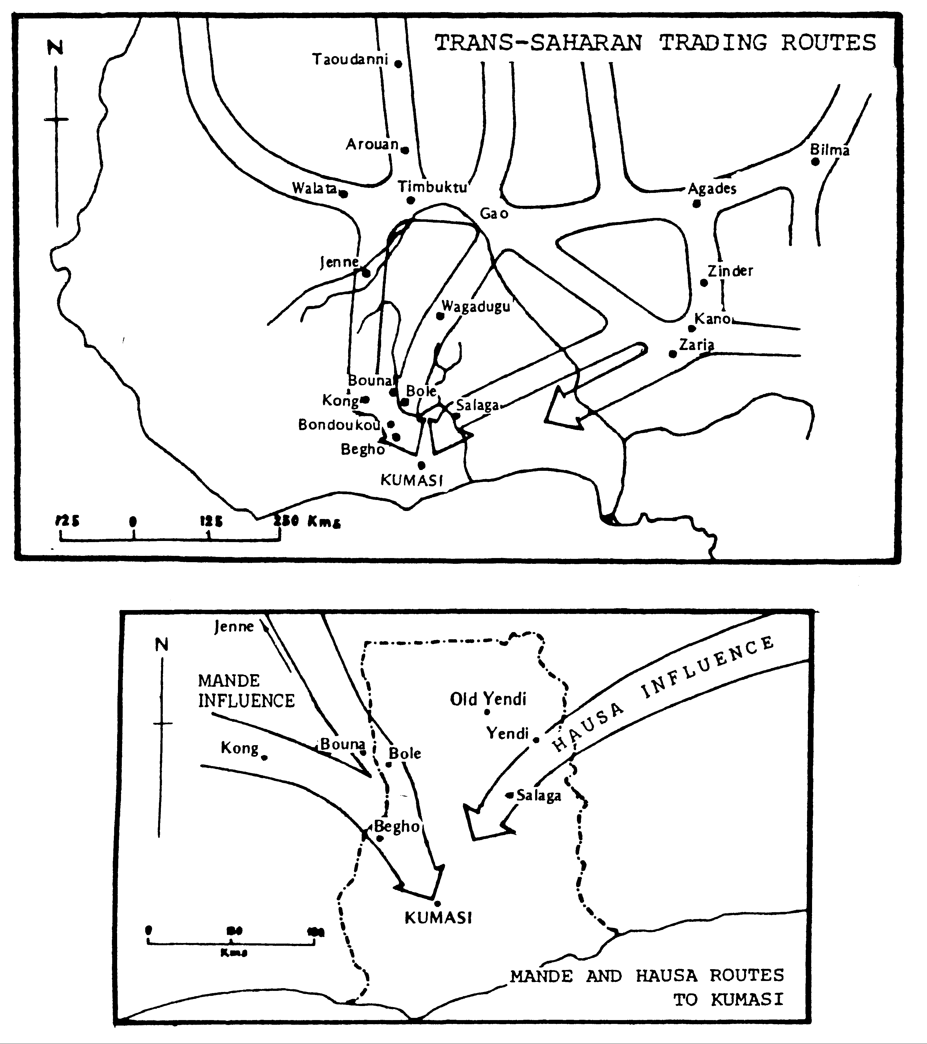
The Gyogo were driven from Kong to Bouna by the Nafana, and settled at Bouna, where there is still a Dyogo/ Ligbi community (at a place called “Ligbi Sora” by the Wangara). E S K Owusu visited Bouna in the 1970s and con-firms that their language is mutually intelli-gible with Ligbi. The Nafana drove them further east to Menji and to Fugla Koora (Sasi, a quarter of Banda) which is about 24 km from Menji. Records in Arabic, now lost, suggested that the date of this movement was around 7-8 centuries ago, and that the Gyogo at that time numbered about 12,000 people. They had large families because there is a Hadith that on the Day of Judgement Allah will praise the Holy Prophet for the number of his followers.
Their occupations were firstly praying to Allah, also small-scale farming and internal barter trade using cowrie shells (kɛkɛ). The main articles traded were gold, diamonds, ornaments, salt, beads, and cowries. [blacksmithing?]
Traditions of origin EO 1976 quotes the following traditions:
1) MENJI "We came from the heavens . . . our leaders were Bomo and Abiyaa" (Menji chief and elders) [should Abiyaa be spelled “Biyaa”];
"We were planted on the Kunasie Hill from time immemorial . . . our leader was Gyasa Kala . . . he was dropped from the heavens" (Namasa chief and elders).
2) BROHANI "We came from Mande in search of a better place . . . our leader was Kwame Gyadugu" (Brohani chief and elders).
“About 1800 Gyaman raiders devastated the Ligbi villages, and the people scattered as far as Wenchi and Kintampo, and north across the Volta to Teselima and Banda Nkwanta. Later many of them returned home.” (EO)
Although Ligbi customs as recorded in Owusu's accounts reflect the beliefs typical of rural societies in Ghana who had several gods, the Muslim influence is indicated by the names of the chiefs and elders who gave him the information, particularly at Namasa and Menji. The chief of Namasa was Nana Sumaila, and his elders included 2 alhajis, a mallam, and several others with Arabic names.
Slavery The great slave raiding campaigns of the 19th century did not reach Ligbi but the Nafana did sometimes invade. The Ligbi themselves bought slaves, who have become assimilated into the Ligbi community.
The slave trade and inter-tribal wars were suppressed when the British and French came to the area.
“We had plenty of slaves. They worked for us on our farms, and we looked after them like our own children but they could not inherit a stool in the house. We did not make war for slaves.
“The western trade route passed through Mande country. Ligbi and Dyula traders operated on the routes from Jenne and Kong into the area of modern Ghana, and some time before 1500 Ligbi traders (or Wangara as they were popularly called) began to settle at Begho; they soon became one of the town's main trading communities.” (EO)
AUTHORITY
There are Ligbi chiefs in Menji, Namasa, and Brohani; at Brohani the chief is appointed by the Krontihene, queen mother, and elders. Some of their elders are alhaji. The Brohani chief died before 2007 and was to be replaced in 2008 or 2009. [has he been replaced? who is the new chief?] (PB)
EO listed 14 chiefs and 12 queen mothers. The chief of Fugla Koora is [name and location please?] There is a black stool which they brought from heaven, but no other stool property, palanquin, or swords. As professional blacksmiths they do not use these things. (EO)
[Menji owes no allegiance to the chief at Banda – does Brohani?]
“The constitution of an Akan state is imposed on this blend of animism and Islamic influence; Namasa, Brawhani, and Menji all have chiefs with typically Akan titles -- Krontihene, Gyasehene, Nifahene, etc -- and they all have queen-mothers in the Akan fashion.” (EO 1976)
INHERITANCE
Inheritance is patrilineal, but this does not affect choice of a chief.
FARMING, HUNTING, FISHING (PB)
Farms may be up to 5 km from the compound. There is a little hunting. Women collect shea nuts and dawadawa pods for sale.
Crops include yams, plantain, cashew trees (small plantations outside Brohani), cassava, millet, groundnuts, guinea corn, tobacco, corn, bambara beans, calabashes,and beans or waakye (the Hausa word); all are cultivated with cutlass and hoe. was The Brohani assemblyman in 2008, Dauda Mohammed, had a farm and employed 5 labourers, but he sent his children to school. There is fishing in the River Kyen. Teak is planted to provide wood for carpentry.
In neighbouring Nsawkaw some cultivate wee for export and local sale; the Catholic priest challenges them without effect. In 2008 there were two madmen, wee addicts, in Nsawkaw; formerly one was a teacher, the other worked in District Administration.
DAILY LIFE (PB)
Houses are built with square or rectangular rooms, roofed with thatch or metal sheets. A row of four rooms plus verandah is a common pattern.
Water Nearly every village has boreholes – Brohani has 11. A dam at Brohani held water continuously for several years, but it failed in 2007 [what about 2008 to 2011? what about Menji?]
Markets People sell their produce through markets in Wenchi, Techiman, and Sampa. Lorries go to these towns daily.
EDUCATION AND HEALTH
Education Primary schools: Menji ?? Brohani: 3 – Presbyterian (headteacher and assistant are Muslims), Islamic, and International (private); 1 JSS. Nearest SSS Wenchi and Sampa. [please enter on this blank table the number of schools at each level in the Ligbi area in 2009 and let me have the figures]

 | schools | enrolment | teachers | % trained | % untrained
K’garten*
Primary
JSS
total
Health CHPS at Brohani and [where else?] .

 | required | at post
doctors
Medical Assistants
Public Health Nurses
Community Health Nurses
Midwives
SRN Diploma
Enrolled nurses
SERVICES
Nearest police station and post office at Nsawkaw.
Food TZ made with maize is the staple food.
Transport Daily trotros &c Brohani to Namasa, Dobor, Menji, Kwame Tenten, Wewa, Bofie. Menji to [?]
Youth associations There are several youth associations in Menji, the main one being the Future Builders Association, which has helped to make blackboards and furniture for the primary school.
RELIGION
estimated %age | Traditional | Muslim | Christian
1986 | 10+% | 80% | <1%
2006 | 5% | 90% ?? | %
most Christians living in the Ligbi homeland are Nafana
Traditional Religion (EO)
“At present all of us practise Islamic religion, but in the past our ancestors worshipped . . . Adingara (the most powerful), Bobiri, Sakara . . . We have offered them sheep and goats to solicit their help to have peace in the state.” In 2006 there was very little evidence of animism.
gods In 1976 there were still annual sacrifices of cow, goat, fowls to the gods including Sirigboe. In 2008 there were a priest and a number of traditional worshippers at Kwame Tenten, 4 km from Menji.
A few other customs survive -- or perhaps have been introduced -- which are typical of non-Muslim tribes in the area.
oaths Tenesegye at Menji – it is taboo to reveal how this oath came to be adopted. Ebenada and Boakyi (behind the rock) at Brohani were both adopted when Samori attacked and threatened to annihilate them in the 1880s [check date].
At the yam festival the first yam is given to the chief, then other yams are deposited on the shrine of the god Adingara. After this people may eat the new yam.
Islam
Every Ligbi town has its mosque. The Ligbi think of themselves as completely committed to Islam. The first Brohani mosque dates from the 1920s; a second mosque was built in 2003 to accommodate larger numbers.
Christianity
1986: Presbyterian and African Faith Tabernacle in Bofie, Church of Pentecost in Brohani.
2008: Catholic in Menji, built by a priest from Papua New Guinea. Church members are probably all Nafana.
SOURCES AND RELEVANT LITERATURE
PUBLISHED OR UNPUBLISHED BOOKS AND PAPERS QUOTED
K Ameyaw Traditions of Banda, IAS, 1970s
E S K Owusu Oral traditions of Sampa, Hani, Debibi, Namasa, Banda, Brohane and Mengye (Menji) -- Brong Ahafo, IAS, Legon, 1976
CONTRIBUTORS
J M Anane, notes and questionnaire answers, GEC, 1985 (JA)
E S K Owusu (EO) (formerly Tain District Chief Executive) 0246753830
ORAL SOURCES
Hon Dauda Mohammed (DM) Brohani 0249448772
Yahaya Mohammed (works at District Assembly) Menji 0242 548402
OTHER RELEVANT LITERATURE
M E Kropp Dakubu "The Ligbi", in The languages of Ghana ed M E Kropp Dakubu
N Levitzon Muslims and chiefs in West Africa, OUP, 1968
Andrew & Janet Persson Aspects of Ligbi grammar GIL, 1980

